Vaccine Web App

By

Kulwinder

Level-6

Final Project

Table of Contents

Project Proposal 3

Goals and Objectives 3

Project Scope 3

Project Specifications 3

Target Audience 3

Project Deliverables 4

Resource Requirements 4

Project Tasks and Milestones 4

Project Assumptions 5

Project Report 5

Detail Design 6

Home Page 6

All Hospital Page 6

FAQ Page 7

All Hospital Admin View 7

All FAQ Admin View 8

My Details Register View 8

My Vaccine Bookings Register View 9

Vaccine Booking Register View 9

Project Testing 10

User Manual 10

Summary 10

System Configuration 10

User Access Levels 10

# 

# Project Proposal

## Goals and Objectives

The main goal or aim of the project is to implement an online web application named “Vaccine Web”. The main purpose of the application is providing a way to person book their vaccine and find the details of Hospital. In this application there are two types of users- admin and registered visitor. Admin has different functionalities as compare to registered visitor. Admin can add, edit, delete and check details of all hospital and maintain the FAQ section of web application.

## Project Scope

The scope of this project is to implement an app named “Vaccine Web” with the help of which user can find any hospital details as well as control their booking of Covid Vaccine. The duration of the project is 20 working days which is equals to 4 weeks.

## Project Specifications

* Admin login/logout
* Add, edit, delete and check details of Hospital by admin.
* Admin can delete, edit and check FAQ details.
* Admin can view personal details of user as well as vaccine booking details.
* Admin can register new admins.
* Registered Visitor can login/logout.
* New Visitor can register.
* Registered Visitor can control their Vaccine Booking process.

## Target Audience

The target audience for this project is the people who want their vaccine booking process at ease. The age can go from 18 plus to 100 plus.

## Project Deliverables

The deliverables of the project are:

|  |  |
| --- | --- |
| **Deliverable** | **Description** |
| Final Report | This will be the final report of the project. |
| Coding | The executable code of the project will go under this. |
| Documentation | This portrays the documentation of the project. |
| Testing | All the test details will be covered in this part. |

## Resource Requirements

* Windows Operating System.
* Microsoft word for documentation.
* Asp.net MVC Framework
* 64-bit Processor and 4 GB or more RAM
* Identity framework- ASP

## Project Tasks and Milestones

|  |  |  |  |  |
| --- | --- | --- | --- | --- |
| **Tasks** | **Week-1** | **Week-2** | **Week-3** | **Week-4** |
| Brainstorming and analysis |  |  |  |  |
| Planning and initial meeting Project Proposal document. |  |  |  |  |
| Database Design and UI Design |  |  |  |  |
| Identity framework implementation |  |  |  |  |
| Coding for admin and reporter |  |  |  |  |
| Testing |  |  |  |  |
| Final Documentation and closing |  |  |  |  |

## Project Assumptions

Following are the assumption made while implementing the project:

* One admin and registered visitor will be registered by default.
* Application will be free and open source.

# Project Report

#### Functional and Non-Functional

|  |  |
| --- | --- |
| Users | Functional |
| Admin | * Login/logout * Register new admins * Admin can add, edit, delete, check details for hospital. * Admin can edit, delete and check details for FAQ. * Admin can view personal details of user as well as vaccine booking details. |
| Customer | * Can view details of hospital and FAQ related to Covid 19 * Can control their process of vaccine booking * New customers can register for free. * Login using valid credentials |
|  | Non- Functional |
|  | * High speed * Fast Loading time * High performance and security * All browsers compatibility. |

## Detail Design

### Home Page

The main landing page of the application. On navigation bar options are- Home, All Hospitals, Vaccine Booking, FAQ, Register, Login.

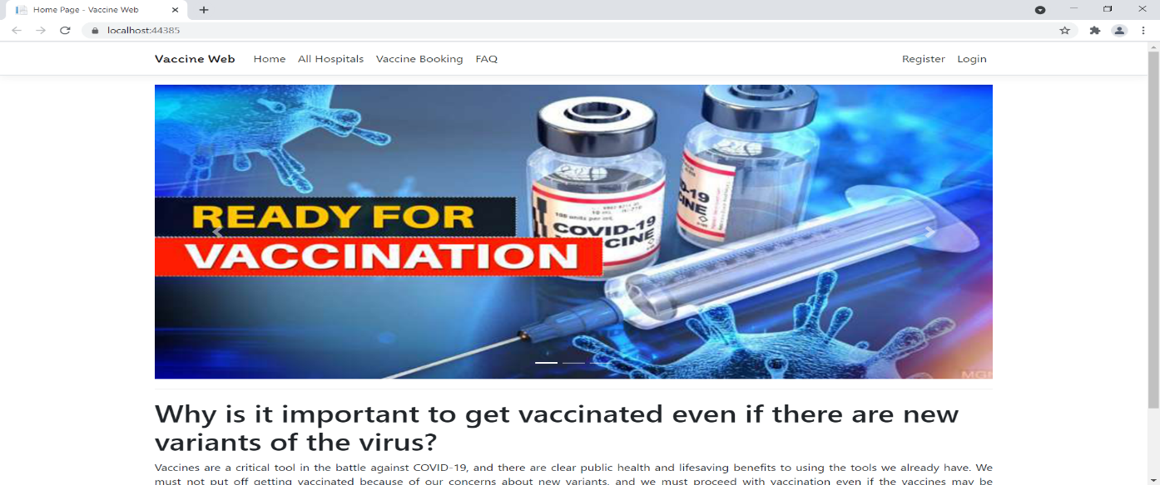

### All Hospital Page

With the help of this page, new visitor can view hospital details

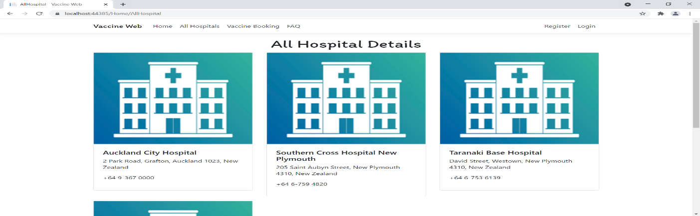

### FAQ Page

With the help of this page, visitor can view FAQ related to Covid 19.

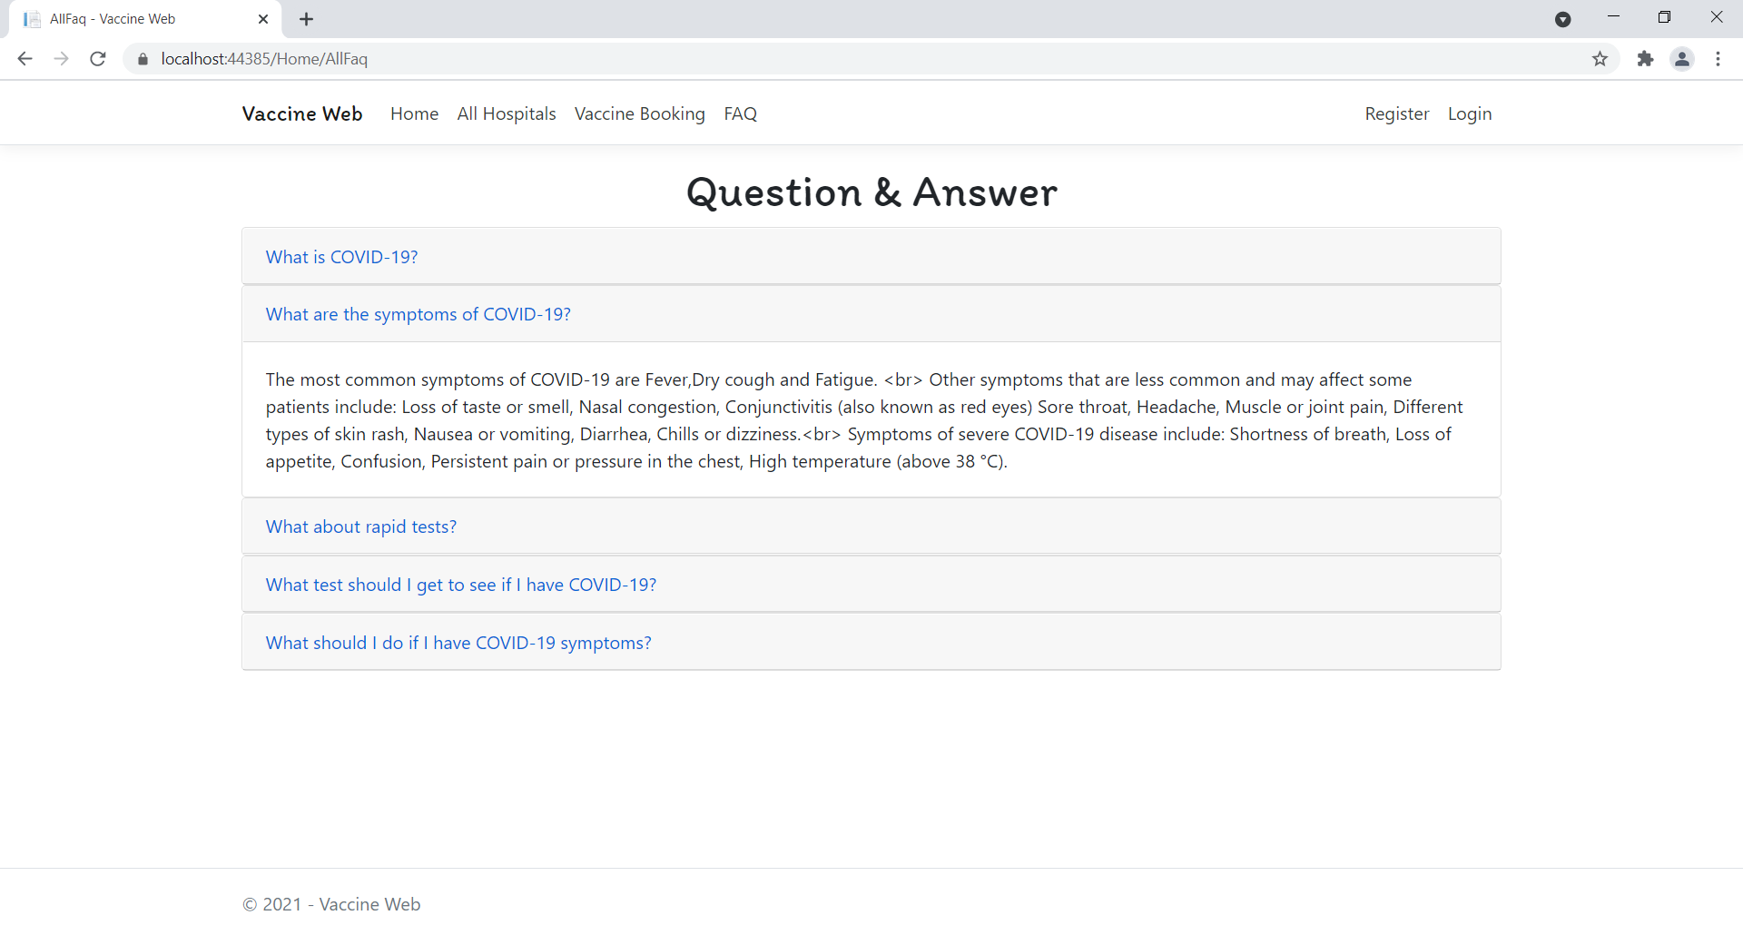

### All Hospital Admin View

This page highlights all the hospital available on the application. Admin can delete and check details of the existing ones.

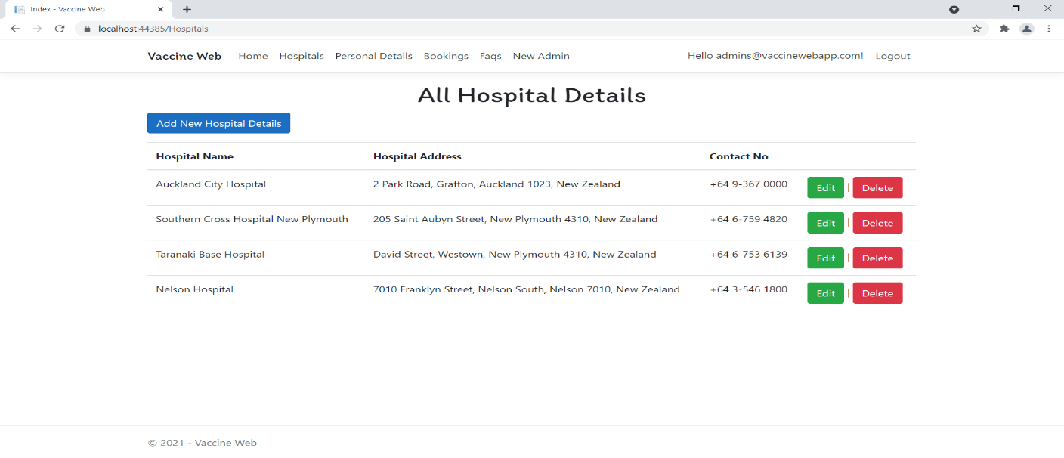

### All FAQ Admin View

With the help of this page admin can manage the FAQ details by editing, deleting and checking their details.

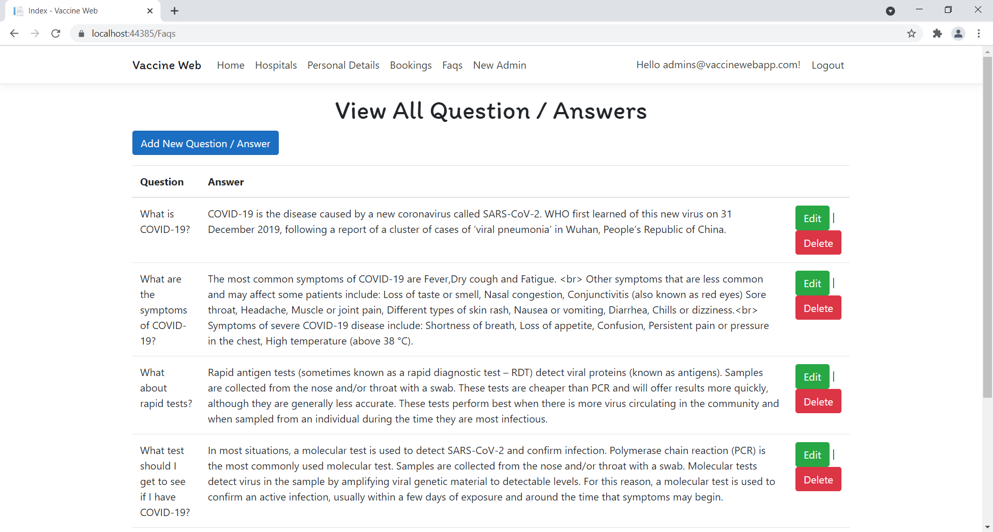

### My Personal Details Register View

With the help of this page Register can view his/her personal details.

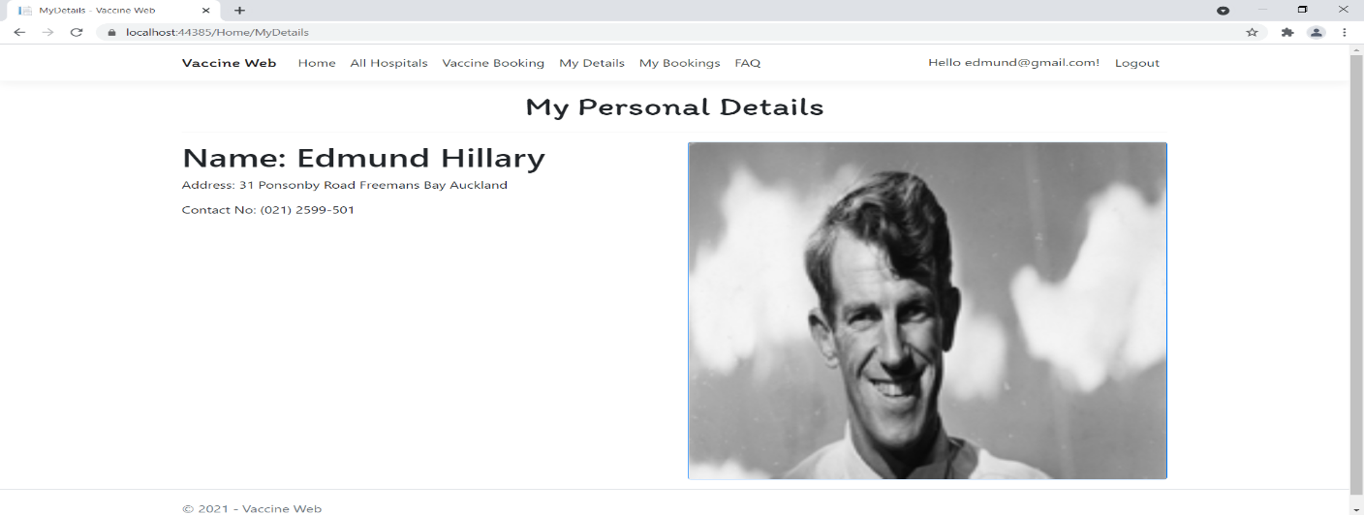

### My Vaccine Booking Register View

With the help of this page register can check the details of the Vaccine Booking and link to cancel booking.

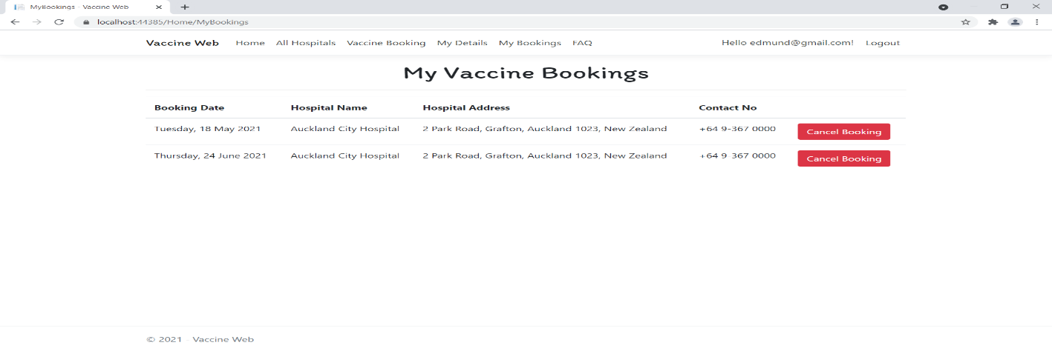

### Vaccine Booking Register View

This page shows the Vaccine Booking Form for Register User

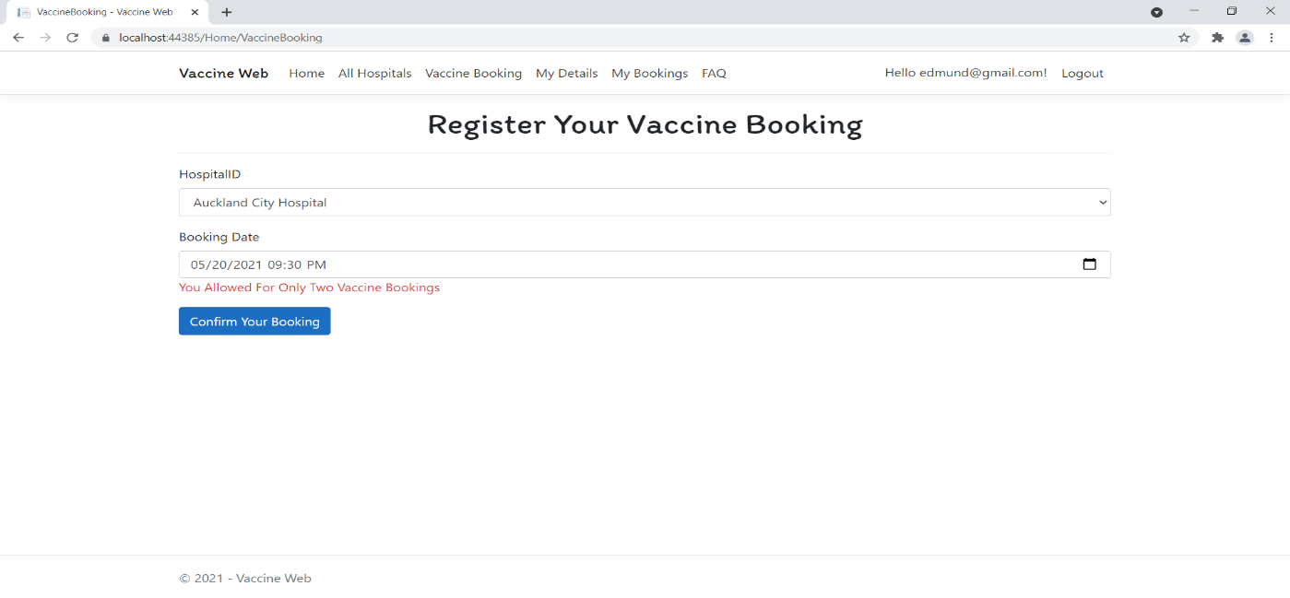

## Project Testing

The testing file for usability testing is attached as [usability test.xlsx](usability%20test.xlsx)

# User Manual

The main purpose of the application Vaccine Web is to help people to ease their process of vaccine booking in different hospital as per their requirement. In this application there are two types of users- admin and registered user or visitor. Admin has different functionalities as compare to registered user. Admin can add, edit, delete and check details of hospital and FAQ entries. Registered User is capable to schedule their vaccine booking as well as their cancellation.

## Summary

### System Configuration

This app will be useful to for distributing mobile information in presentable format.

### User Access Levels

Only registered users can access the features of this application.

* **Admin:** Admin has full access of the app can register new admins.
* **Registered Visitor:** New visitor can register and existing can login using their own credentials. They have limited access.